Documents Classification Report

1. Introduction
   1. This task includes classifying documents for their content.
   2. The Classification problem was whether the documents discussing company purchasing or not.
   3. The input data includes CSV containing:
      1. URL for the document
      2. Description
      3. Title
      4. Content
      5. Classification
2. Approach
   1. This task is formally a binary classification problem.
   2. Several classification models were tested:
      1. Decision tree
      2. Random forest
      3. KNN
   3. Every one of these models was tested against each of the fields separately with small changes in model properties for optimization:
      1. Title
      2. Description
      3. Content
3. Data Insights
   1. Contains 3 languages:
      1. English
      2. Italian
      3. Spanish
   2. The data is imbalanced (~2500 T / ~17,500 F)
      1. 
4. Preprocessing
   1. Includes Data cleaning:
      1. Lower casing
      2. Stripping multiple white spacing
      3. Removing stop words:
         1. English
         2. Italian
         3. Spanish
      4. Stripping alphanumeric characters
      5. Stripping numeric characters
      6. Stripping Punctuation
   2. Creating indices/tokens dictionary using all of the documents.
   3. Preparing indices/tokens matrix from all of the documents.
5. Model training
   1. There are several approaches for handling data imbalance, I will try several methods for solving this issue:
      1. Using different algorithms
      2. Resampling the data-set
         1. Under expressing negative classifications by removing negative samples.
         2. Over expressing positive classifications by duplicating Positive samples.
         3. Both of the above
   2. I have created the indices matrix using doc2idx what made it optional for me using the vector for model training.
6. Results – the order for each model results are (normal data set, under expressed F class, over expressed T class)
   1. Simple decision tree classifier with original data set:
      1. Attached below the results for decision tree classifier for the fields => title, description, content:
      2. 
      3. 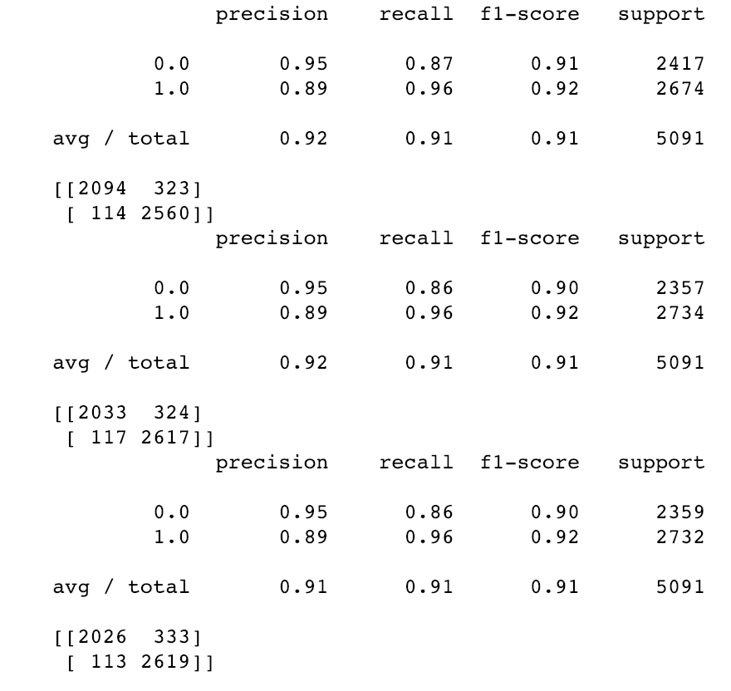
      4. 
   2. Random forest classifier with original data set:
      1. Attached below the results for random forest classifier for the fields => title, description, content (300, 1000, 1000 sub trees):
      2. 
      3. 
      4. 
   3. KNN Classifier:
      1. First was finding best k for the model, attached k measurements for original data set for fields => title, description, content:
      2. 
      3. 
      4. 
      5. Attached below the results for KNN classifier using best k for the original dataset and fields => contents, titles, description
      6. 
      7. 
      8. 
7. Model choosing –
   1. I have chosen using random forest model with 1000 sub trees for document title (results can be found on 6=>b=>iv=>last table).
   2. This model maximizes the total accuracy, precision and recall.
8. Instructions for using the model:
   1. Github Repository contains 2 notebooks.
      1. Creating the models (all of them).
      2. API – containing just the method itself.
      3. requirements.txt – all packages required.
   2. The notebooks used 2 other datasets beside the original data.
      1. Link will be sent separately due to git size limit.
   3. The model, the word to index dictionary will also be sent separately.